Moving from Manhattan to Miami through the Eyes of a Data Scientist

**A. Introduction**

Manhattan is known regionally as the City and urban core of the New York Metropolitan Area. It is the most densely populated of the five boroughs of New York City. Manhattan serves as the city's economic and administrative center, cultural identifier, and historical birthplace.

Miami is a coastal metropolis located in southeastern Florida in the United States. It is the third most populous metropolis on the East Coast of the United States.

According to the Empire Center Publication [1], New York's estimated population decreased by 0.65% during 12 months ending July 1, 2020, while the population of Florida increased by 1.12% during the same time.

Add alt text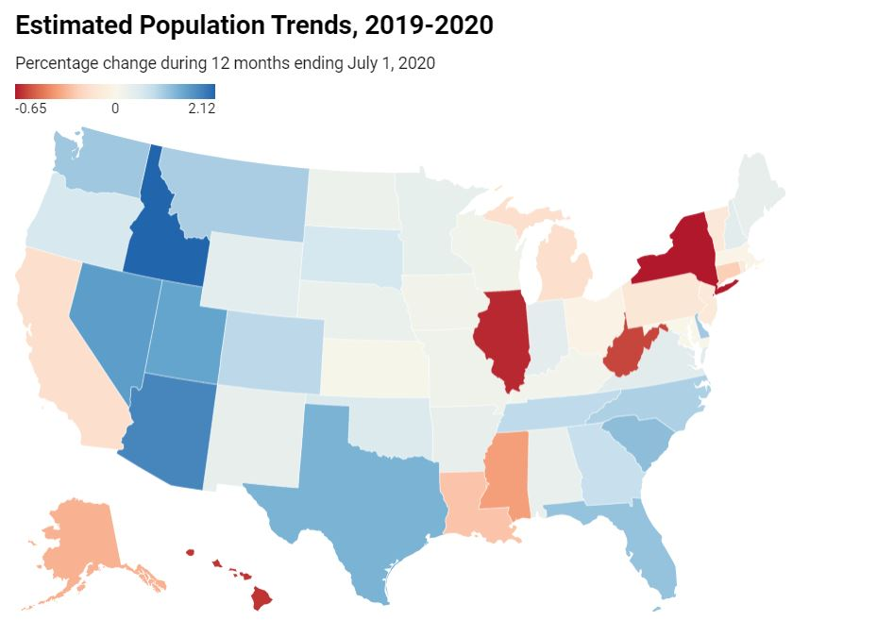

According to the Businessinsider article[2], many individuals are fleeing New York City and are moving to Florida as the pandemic makes remote work look more permanent. When people move to new places, they might not want to change their lifestyles. The ones who get used to hanging out around some specific places within the walking distance might want to be close to similar kinds of places in their new location if they decide to move.

With that in mind, I decided to analyze the venue similarities for each neighborhood between Manhattan and Miami for people who are thinking of moving to Miami from Manhattan.

When the similarities are considered, we can create a map and information chart where the neighborhoods are placed in Manhattan and Miami and each neighborhood is clustered according to the venue density.

**B. Data Description**

To consider the problem we can list the data as follows:

* List of each neighborhood in Miami and Manhattan[3]
* Geographical coordinates of each neighborhood in Miami and Manhattan[3]
* Venues of each neighborhood by given coordinates in Miami and Manhattan from Foursquare[4]

**C. Methodology**

1) I used Request and Beautiful Soup for scarping and parsing the neighborhood data. Then I cleaned the data by dropping the unnecessary and irrelevant information. In addition, I converted the data to pandas data frames in Python.

*Miami Neighborhoods and corresponding geographical coordinates:*

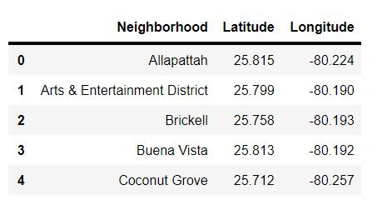

*Manhattan Neighborhoods and corresponding geographical coordinates:*

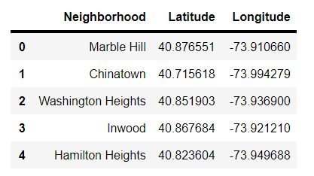

2) In python, I used **Folium** library to visualize the geographic details of Miami and Manhattan along with their neighborhoods. In addition, I created a map of Miami and Manhattan with their neighborhoods superimposed on top of each other. I used latitude and longitude values to get the visual as below:

*Each neighborhood in Miami:*

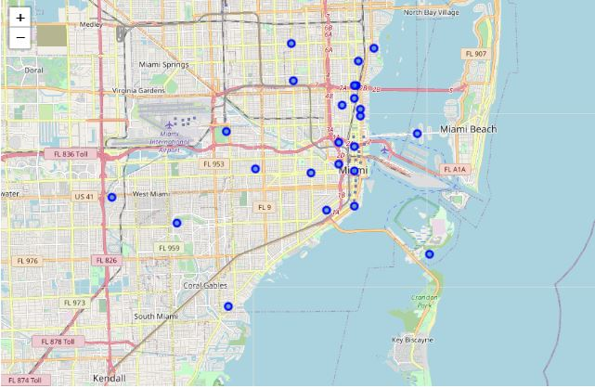

*Each neighborhood in Manhattan:*

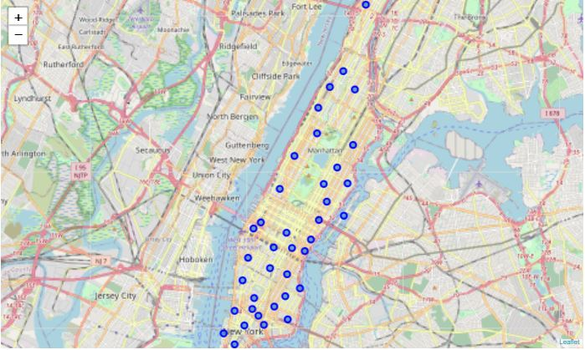

3) After merging Miami and Manhattan datasets, I utilized the Foursquare API to explore the neighborhoods and segment them. I designed the limit to **100 venues** and the radius to **500 meters** for each borough from their given latitude and longitude information. 5088 venues returned from Foursquare. Below is the list of venue names, venue categories, latitude, and longitude information from Foursquare API.

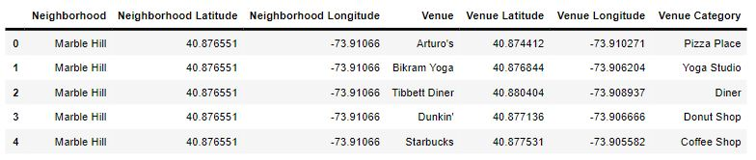

4) I would like to see how many venues are located in any given coordinate for each neighborhood. I grouped the neighborhood column and counted the number of venues for each. Below graph represents this information:

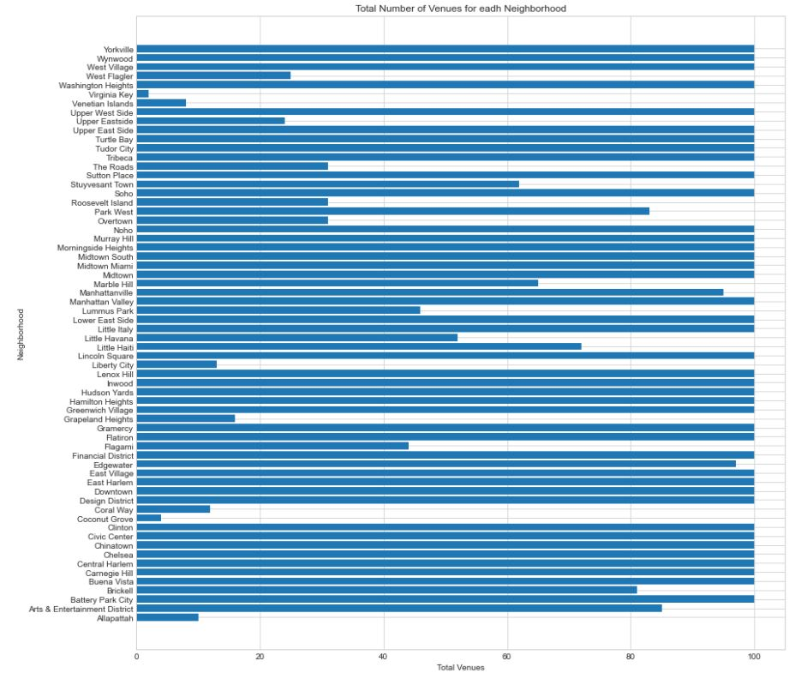

5) Next, I grouped rows by neighborhood using the mean of the frequency of occurrence for each category. Then, I sorted the frequency of occurrences of each category by descending order and took the most frequent 10 venues for each neighborhood.

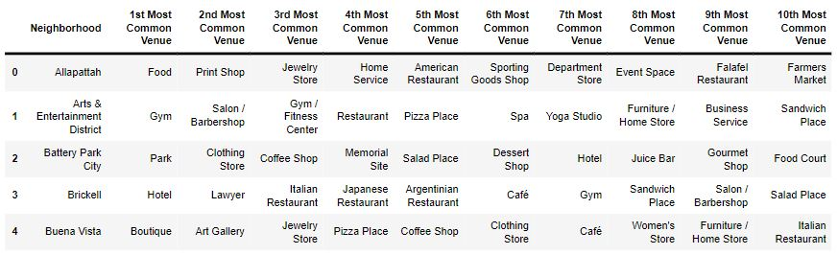

6) After the most common venues are chosen for each neighborhood in Miami and Manhattan, I used the **K-means clustering ML** algorithm to cluster the neighborhoods. After analyzing the results with the different numbers of cluster centers "k", I decided to conduct my analysis with k=7. The reason for choosing k=7 is to find as many unique clusters that have similar neighborhoods from each city: Manhattan and Miami.

*Please see the merged table below after the clusters are chosen:*

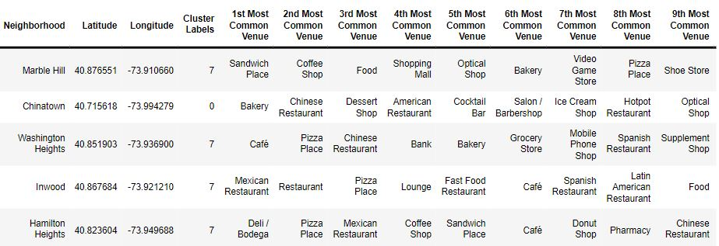

**D) Results**

After all the neighborhoods were assigned to the clusters, I used the folium maps to illustrate the clusters in Miami and Manhattan.

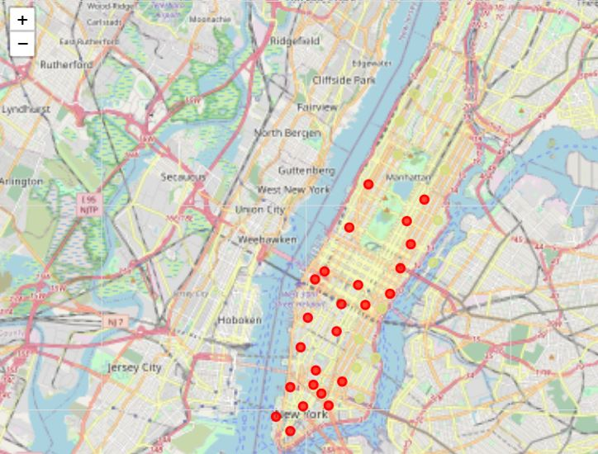

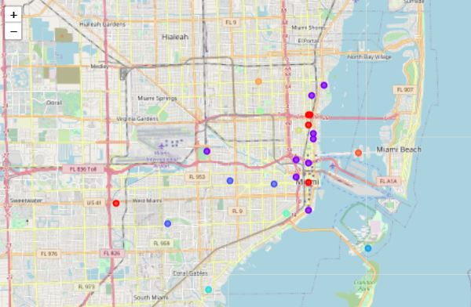

As it is seen above, there are five red circles and one yellow circle in Miami that are assigned to the same clusters in Manhattan. Let's analyze which neighborhoods they are and what are the most common places in those neighborhoods.

*Red Cluster:*

Add alt text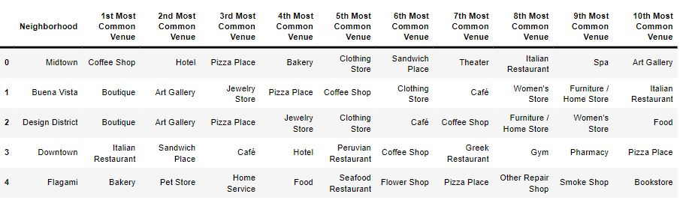

*Yellow Cluster:*

Add alt text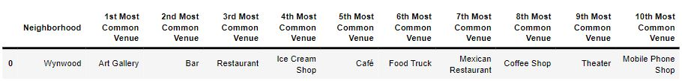

As it is shown above, Midtown, Buena Vista, Design District, Downtown, and Flagami are in the red clusters and Wynwood is in the yellow cluster. Those neighborhoods could be the best options for New Yorkers in terms of the most common venues.

**E) Discussion**

This paper focuses on clustering the neighborhoods by most common venues around each neighborhood in Miami and Manhattan. As we all agree, there are other significant factors that impact the decision of moving to a particular neighborhood besides the venues such as house prices, crime rate, local schools, commute times, community life, and others. When conducting more detailed research, these factors should be considered as additional variables.

I used the K-means clustering Machine Learning algorithm as part of my study. I set the optimum k value to 7. However, the results might be different if the k is set to another value. In addition, there are other clustering algorithms that can be used to compare the results.

**F) Conclusion**

Considering only the specific variables that are used in this paper, I can suggest New Yorkers move to Midtown, Buena Vista, Design District, Downtown, Flagami, and Wynwood in Miami. This paper can be the starting point of a bigger location clustering research all over the world. I am more than happy to work with a bigger data set to make different recommendations for people who would like to move, companies who would like to open new offices and explore other possibilities.

Tunahan Gumuskaya

3/21/2021

**G) References:**

* [1] [Empire Center - Population Decline in NY](https://www.empirecenter.org/publications/new-york-had-largest-population-decline/)
* [2][Business Insider- Bankers and Wall Street executives are fleeing New York and moving to Florida](https://www.businessinsider.com/pandemic-prompts-wall-street-to-look-south-for-floridas-life-and-work-benefits-2020-12)
* [3] [List of Neighborhoods](https://en.wikipedia.org/wiki/List_of_neighborhoods_in_Miami)
* [4] [Foursquare API](https://developer.foursquare.com/)